Add JB L-E Shared Calendar
- Go to the calendar icon on Outlook (bottom left corner)
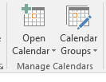
- Click “Open Calendar” on the top banner
- Select “From Address Book”
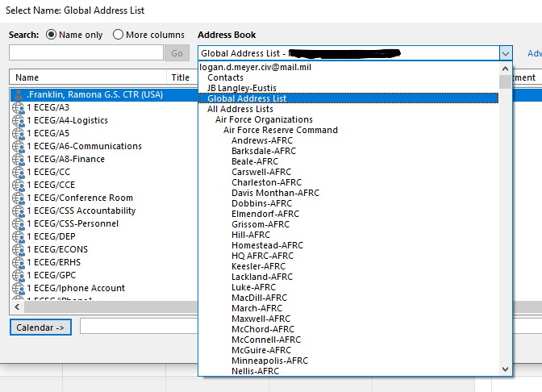
- In the right search bar at the top of the pull-out labeled “Address Book,” select “Global Address List” from the dropdown menu
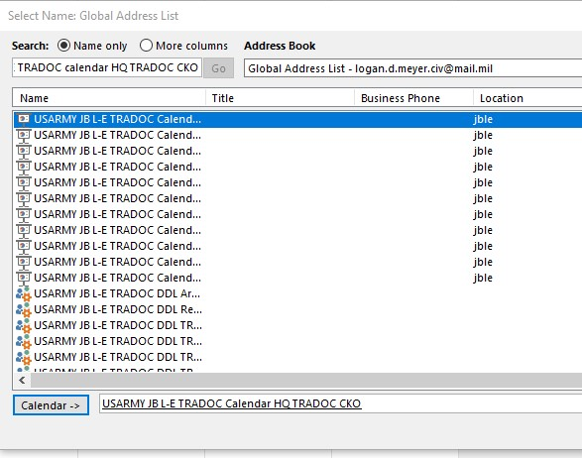
- In the search bar, type “USARMY JB L-E TRADOC Calendar HQ TRADOC CKO” and double click the first option
- Select “OK” in the bottom right

