UNITED STATES ARMY

TRAINING AND DOCTRINE COMMAND

nh4fvhac[1]

CIVILIAN HONORARY

AND

PUBLIC SERVICE

AWARDS

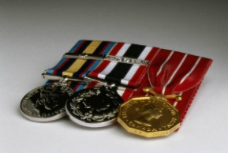

PROCESSING GUIDE

(UPDATE)

Prepared by

Civilian Human Resources Directorate (CHRD)

Office of the Deputy Chief of Staff, G-1/4

Joint Base Langley Eustis, Virginia

4 April 2019TABLE OF CONTENTS

**Page**

**I. PREFACE i**

**II. PROCESSING HONORARY AWARDS 1-3**

**DESCRIPTION WITH PHOTOS OF HONORARY AND PUBLIC SERVICE AWARDS – Figure 1 4**

**SAMPLES:**

**DA Form 1256 – Figure 2 5**

**Biographical Data – Figure 3 6**

**Justification – Figure 4 7-8**

**History of Awards – Figure 5 9**

**Proposed Citation – Figure 6 10**

**Letter of Lateness – Figure 7 11**

**CHECKLIST – Figure 8 12**

**ROUTING PROCESS – Figure 9 13**

**III. PROCESSING PUBLIC SERVICE AWARDS 14-15**

**SAMPLES:**

**DA Form 1256 – Figure 10 16**

**Biographical Data – Figure 11 17**

**Justification – Figure 12 18-19**

**History of Awards – Figure 13 20**

**Proposed Citation – Figure 14 21**

**CHECKLIST- Figure 15 22**

**ROUTING PROCESS – Figure 16 23**

**AWARDS FOR APPROVAL AT DA AND/OR DoD Form – Figure 17 24**

**IV. DELEGATION OF AUTHORITY FOR CIVILIAN HONORARY AND PUBLIC SERVICE AWARDS 25**

**I. PREFACE**

**Introduction. In the midst of budgetary and personnel constraints, commanders, managers, and supervisors need to be creative in trying to “get the most for the dollar.” The process of maximizing the potential for success prompted the idea that managers must ensure that every employee is “doing the right thing, right the first time, all the time.” Behavior which is rewarded will be repeated by employees. The challenge is how to motivate the members of a diverse work force and promote team building.**

**The Incentive Awards Program can be a powerful tool if properly aimed at rewarding performance which is directly related to specific goals and objectives.**

**Purpose. This guide provides procedures on how the civilian incentive awards program can be used more effectively. It also consolidates as much information about awards processing as possible into one document. Army Regulation 672-20 governs the awards described in this document. This guide is focused on the most commonly used awards. The information in this booklet is provided as a desktop tool and is not a substitute for governing laws and regulations. Samples and charts have been included to assist you in putting together a complete award nomination package.**

**Internal Controls. Commanders should ensure that internal control procedures are being followed in order to have an effective incentive awards program. Improper use of awards could result in morale problems and ineffectiveness of mission accomplishment. An effective incentive awards program means:**

**a. Granting recognition based solely on merit and not as a substitute for other personnel actions.**

**b. Selecting the most appropriate form of recognition which is motivating to the employee(s) and cost effective to the organization.**

**c. Publicly recognizing employees for their exceptional performance.**

**e. Presenting awards as promptly as possible.**

**General Information. Award nominations must be reviewed/approved at least one level above the nominator unless the nominator is the commander.**

**Award nominations contain privileged information and should not be made available to anyone outside the approval process. Nominees should not be informed he or she has been recommended for an award until it is approved.**

**i**

**It is very important that timelines for submitting awards are adhered to in order for the award to be presented in a timely manner. There will be occasions when this is not feasible and a letter of lateness must be included in the nomination package.**

**All award nominations must be submitted to the organization’s awards administrator point of contact prior to submitting to the TRADOC Awards Executive Secretary. The organization’s awards administration should review for correctness.**

**The TRADOC Awards Executive Secretary will not release nominations requiring review by the TRADOC Incentive Awards Review Board until all required documents has been submitted. The EEO Director and CPAC Director must fully complete DA Form 1256 (dated Feb 2019), Part II; ‘yes’ or ‘no’ must be checked. If ‘no’ is checked a full explanation of the issue must be included with the nomination package.**

**ii**

## II. PROCESSING HONORARY AWARDS

**Purpose. The following information is provided as a quick reference guide for processing honorary incentive awards that require CG/DCG, TRADOC approval. NOTE: All award nominations must be submitted to the organization’s awards point of contact before sending to the TRADOC Awards Executive Secretary.**

**Background. Department of the Army Honorary Incentive Awards policy is outlined in AR 672-20, Chapter 8. A description of these honorary awards is provided at FIGURE 1.**

**1. Honorary award nomination packages must include the following:**

**a. DA Form 1256 (dated Feb 19), Incentive Award Nomination and Approval – FIGURE 2. DO NOT use abbreviations or acronyms in block 3 or block 4. Form must be forwarded to TRADOC Awards Executive Secretary in “PDF’ format.**

**NOTE: This form no longer requires a Social Security Number.**

**b. Employee biographical data (for award nominations for the Department of Defense Distinguished Civilian Service Medal - FIGURE 3.**

**(1) Name.**

**(2) Title and grade.**

**(3) Education and degrees.**

**(4) Employment record.**

**c. Justification – FIGURE 4: The justification (no more than two single-spaced pages) for the award must refer to specific achievements/accomplishments.**

**d. History of significant awards with dates (mm/yy) – FIGURE 5. List the most current awards first. Honorary awards typically follow a progressive sequence of recognition and may be given to employees any time in their career, including occasions such as reassignment, transfer, separation, and retirement. These situations do not form the basis for a nomination. Employee’s award history can be obtained through Defense Civilian Personnel Data System (DCPDS), Army Regional Toolset for GS employees. Contact your CPAC for DoD Performance Management and Appraisal Program (DPMAP) employees.**

**e. The Equal Employment Opportunity (EEO) Office and Civilian Personnel Advisory Center (CPAC) Certifications using DA Form 1256 (for awards that require CG/DCG, TRADOC approval). The EEO office must affirm (check YES or NO, sign, and date) that the nominee’s records have been reviewed and that there is no current or past EEO complaint against the nominee. The CPAC must certify (check YES or NO, sign, and date) that the nominee has no current or past adverse actions based on**

**performance or conduct in the nominee’s record. If there are EEO and/or other adverse action issues, the nomination package must include the particulars of the case. Electronic mail certification is acceptable and will be included with the nomination. When adverse EEO or CPAC findings are documented, the nominating official must review the findings and determine whether to forward the award nomination for approval. If the award approval authority disagrees with the nominator’s determination, the package will be returned to the nominator with reasons for the disapproval.**

**f. Proposed Citation – FIGURE 6.**

**(1) Prepare a one paragraph (approximately 90-95 words) proposed citation. The citation should highlight two to three of the individual’s significant achievements. Avoid using acronyms unless they have been clearly defined.**

**(2) Include the scheduled date award will be presented to the nominee and annotate if nominee is retiring; departing current job, or receiving the award for exceptional performance of duties.**

**(3) Must show period covered for the award. Period being recognized should not cover receipt of another honorary award.**

**g. Letter of lateness – FIGURE 7. Award nominations for approval by the Commanding General, TRADOC, must be forwarded to the DCS, G-1/4, CHRD, 60 days prior to the presentation date. This allows adequate time to process thru the IARB (if applicable). If the award is not submitted timely to assure proper processing, the package is considered late and must include a letter of lateness from the organization. Nominations arriving late with no explanation will be returned to the organization. If the award nomination is for approval by the Secretary of the Army, it must be submitted to the TRADOC Executive Secretary 90 days prior to the presentation date.**

**h. Award Processing Checklist – FIGURE 8. Use the checklist to ensure all documentation has been included to process the award nomination.**

**i. Routing Process – FIGURE 9. Routing for honorary award nominations after received by the TRADOC Executive Secretary.**

**2. Additional processing tips are as follows:**

**a. The DA Form 1256, biographical data (if applicable), history of awards—honorary and monetary, justification, citation, and EEO Office and CPAC certifications should be scanned and sent electronically to althea.e.chavis.civ@mail.mil.**

**2**

**b. If the honorary award is for approval by the Secretary of the Army or higher level, follow the preparation guidance in DA Pamphlet 672-20, chapters 2-3 and 2-4 and forward the package to email address above.**

**c. All award nominations requiring approval of the Commanding General, TRADOC and the Deputy Commanding General, TRADOC must show the installation commander’s or staff principal’s approval on DA Form 1256, Part IV, Block 10.**

**d. All documents must be free of typographical and grammatical errors.**

**NOTE: If approval is the Secretary of the Army include the following with nomination:**

**Date of presentation**

**Time of presentation:**

**Location of ceremony:**

**If retiring, Month and Year:**

**Delivery address to send certificate and medal:**

**If requesting delivery via FEDEX add billing information (include with address a contact and commercial phone number):**

**3**

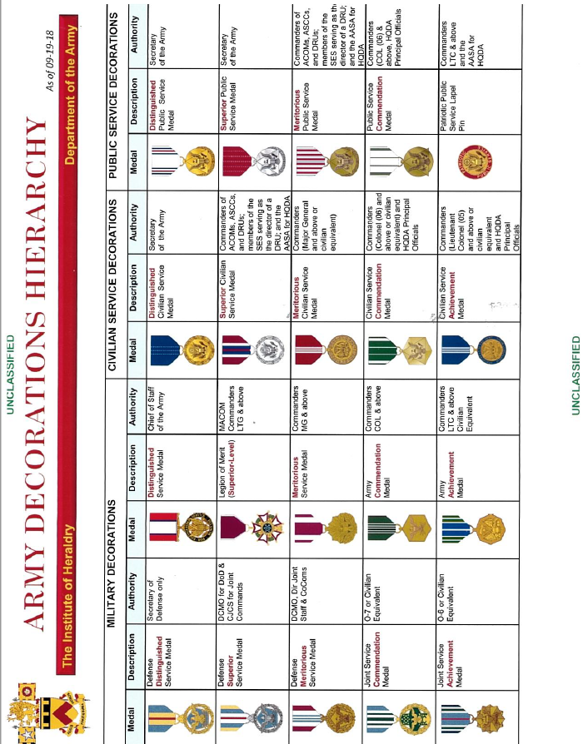

**Figure 1. Description with Photos of Honorary and Public Service Awards**

**(Refer to Delegation of Authority on Page 25)**

**4**

SAMPLE DA FORM 1256 for Civilian Honorary Awards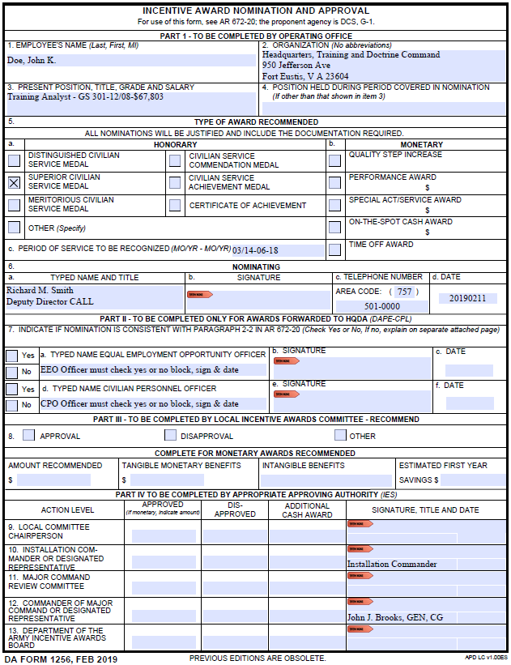

**Figure 2. DA Form 1256 5**

BIOGRAPHICAL DATA

Name: Mr. John W. Doe

Title and Grade: Human Resources Specialist, GS-13

Education/Training:

Apr 91–Apr 91

EEO for Managers Fort Belvoir, VA

Mar 90–Mar 90

Labor Relations Course Carlisle Bks, PA

Oct 85–Dec 85

College (Communications) Oklahoma Univ, OK

May 79–Jun 79

Basic Supervision Course Chambersburg, PA

May 77–Jun 77

Personnel Staffing Course Ft Ben Harrison, IN

Jan 67–May 68

College (English/Philosophy) Christian Br Col, TN

Apr 68–Apr 68

Briefing Techniques Ft Ben Harrison, IN

Sep 64–Jan 67

College (English/Philosophy) Mt Saint Mary’s Col, MD

Employment:

Apr 87–Present Human Resources Specialist (GS-13) HQ TRADOC, Ft Monroe, VA

Nov 82–Apr 87 Personnel Staffing Specialist (GS-12) US Army Engineer Div, GE

Dec 77–Nov 82 Personnel Staffing Specialist (GS-11) WSMR, NM

Oct 76–Dec 77 Labor Relations Specialist (GS-9) WSMR, NM

Oct 75–Oct 76 Employee Relations Specialist (GS-7) WSMR, NM

Apr 74–Oct 75 Personnel Assistant (GS-5) USATECOM, MD

#### Figure 3. Biographical Data – Honorary Awards 6

#### SAMPLE

#### SUPPORTABLE JUSTIFICATION

**for**

**Meritorious Civilian Service Medal**

**Mr. John W. Doe is nominated the Meritorious Civilian Service Medal for the outstanding performance of his duties as Deputy, Garrison Commander, Presidio of Monterey and the Ord Military Community, from September 1999 to June 2003.**

**During this time frame, Mr. Doe proved himself to be the consummate professional, one whose guidance and counsel is sought by all around him because of his calm, thoughtful manner and his impeccable knowledge of installation management. He showed a remarkable ability to work with people and effectively organize large, complex tasks and organizations.**

**He was a caring, compassionate leader with high moral standards who sets the example for the civilian workforce. He had the presence of mind and self-confidence to act correctly during critical and short-fused situations. He always did the right thing at the right time and for the right reasons.**

**Within months of his assignment, Mr. Doe successfully negotiated the settle of a major merit system protection board complaint that saved the garrison tens of thousands of dollars.**

**He used common sense and his vast Army experience in tackling problems. He was extremely logical and thoughtful in his decision-making and problem-solving process. He originated well thought ideas and did not await direction or guidance to organize and proceed with the task at hand.**

**Mr. Doe eagerly took on the additional duty of the installation director of resource management for 6-months when the outgoing director was not immediately replaced. He performed these duties in the same, impeccable manner that he does all other things. He accomplished all of his tasks in this area in a superb manner.**

**As the appointing authority, he developed and implemented a program for administering reports of survey that reduced the large backlog of surveys that existed when he arrived, and he improved the rate of recovery of damages by the government significantly in the process.**

**He effectively and efficiently established position management control over all civilian positions and managed the civilian work force in a superb manner. He assisted the installation Chief of Staff and Installation commander in this area, and he was the recognized expert on civilian personnel and management matters. He directed the**

**7**

**complete review of all civilian positions descriptions in the garrison over a 3-year period that will lead to a more effective and efficient use of our scarce authorizations. He had an aggressive mentoring relationship with several subordinates that ensured that development of future civilian leaders for the installation and for the Army.**

**He had a remarkable ability to work with people and organize tasks, as shown by his pivotal role in the A-76 studies for the installation. He personally managed appeal responses that allowed the installation to prevail in the appeal process quickly, and to continue the march toward implementation of the winning most efficient organizations.**

**Mr. Doe was chosen by the Assistant Chief of Staff for installation management to play a leading role in the development of an official career program for civilian deputies.**

**He developed, implemented, and executed a program that drastically reduced the number of delinquent hand receipt reviews, going from more than fifty to less than ten within a one-year period.**

**He was the installation subject-matter-expert on all things involving the transformation of installation management, and the installation management agency.**

**He always maintained a useful, helpful, and appropriate relationship with the union. He was an accomplished negotiator.**

**Mr. Doe always had a complete grasp of the Commander’s vision and intent. He understood his Commander’s rhythm and successfully anticipated his desires. He skillfully represented the garrison and installation in all forums. Mr. Doe was a tested and proven professional who leads by example and sets the benchmark for the civilian work force.**

**NOTE: A well-supported justification describes the employee’s achievements/ accomplishments in detail for the period of service being recognized. Any periods of service recognized by a previous honorary award may not be used as justification for the current award. Justifications should include descriptions of programs, plans, projects, or events developed, created, and orchestrated by the individual. Cite any situations where the employee achieved savings or avoided unnecessary production and administrative costs.**

**A weak justification fails to provide a complete picture of the employee’s accomplishments. It may only cite the employee’s position and state that he/she did a great job or served with distinction. Specific examples of accomplishments strengthens the justification.**

**Nominators must avoid inflated language and remain true to the actual achievements.**

#### Figure 4. Supportable Justification – Honorary Awards

**8**

**SAMPLE   
 HISTORY OF PREVIOUS HONORARY AWARDS**



**Figure 5. History of Previous Awards – Honorary Awards**

**9**

**SAMPLE**

**PROPOSED CITATION**

**For exceptional service as Deputy, Garrison Commander, Defense Language Institute, Presidio of Monterey, and the Ord military community, during the period September 1999 to June 2003. Mr. Doe displayed the highest levels of leadership and management skills, showing that he was the consummate professional employee. Mr. Doe was instrumental in successfully negotiating the settle of a major merit system protection board complaint saving the garrison tens of thousands of dollars. Mr. Doe’s exceptional performance, professionalism, and dedication to duty reflect great credit on him, the Defense Language Institute, the Ord military community, and the United States Army Training and Doctrine Command.**

**Presentation of this award is scheduled for (indicate a date).**

**NOTE: The citation should start with the statement “For exceptional service,” followed by the employee’s official position, organization, duty location, and the period of recognized service.**

**Next, two or three key accomplishments of the employee for the period specified in the citation.**

**In conclusion, some distinctive qualities should be described about the employee. For example, Mr. Doe’s exceptional performance, professionalism, and dedication to duty reflect great credit on him, (his organization), the Training and Doctrine Command and the United States Army.**

**The citation should be one paragraph in length consisting of approximately 90 to 95 words. The recommended print is Arial font, 12 pitch, justified.**

**Figure 6. Proposed Citation – Honorary Awards**

**10**

SAMPLE

Letters of Lateness

**(Office symbol) (Date)**

**MEMORANDUM FOR COMMANDER, TRADOC**

**SUBJECT: Letter of Lateness**

**1. Request approval of enclosed award nomination for Mr. John Doe, Human Resources Specialist, for the Meritorious Civilian Service Medal.**

# **Example a**

**2. Reason - On (date), Mr. Doe was notified he had been accepted for a position at Fort Monroe and will be departing on (date).**

**3. It is appropriate that Mr. Doe be recognized for his exceptional accomplishments to the G-1/4, CHRD, for the following reason (brief statement).**

**4. POC is (name and phone number).**

# **Example b**

**2. Reason - Mr. Doe announced on (insert date) that he would be retiring which only allowed 2 weeks to process this award.**

**3. It is appropriate that Mr. Doe be recognized, upon his retirement, for his exceptional accomplishments to the G-1/4, CHRD, for the following reason (brief statement).**

**4. POC is (name and phone number).**

**COMMANDER or STAFF PRINCIPAL**

**SIGNATURE BLOCK**

**NOTE: Above are two examples of reasons for requesting the TRADOC, Commanding General’s approval for late submissions of award nominations. There may be other valid reasons the nominator may have to support the letter of lateness.**

#### Figure 7. Letter of Lateness – Honorary Awards

**11**

**HONORARY**

**AWARD PROCESSING**

**CHECKLIST**

**Review award packet using checklist to ensure all applicable documentation has been included.**

**Honorary Award Nomination**

**DA Form 1256, Incentive Award Nomination and Approval (signed by the nominator and senior approver.**

**Biographical data (if applicable).**

**Justification (provide achievements/accomplishments and resulting benefits for the period nominated). NO acronyms or abbreviations.**

**Citation highlighting one or two significant achievements. NO acronyms or abbreviations.**

**List of previous honorary and cash awards (Month/Year received).**

**CPAC certification. (Certification may be provided in PART II of the DA Form 1256 or as a separate statement from the CPAC Director or Human Resources Specialist.)**

**EEO Office certification. (Certification may be provided in PART II of the DA Form 1256 or as a separate statement from the EEO Officer or EEO Specialist.)**

**Coordination with other organizations (if applicable).**

**Letter of lateness (if applicable). NOTE: Refer to Part II, 1g, of this document.**

#### Figure 8. Award Processing Checklist – Honorary Awards

**12**

**ROUTING PROCESS for HONORARY AWARD**

**Routing of award nominations for:**

**Distinguished Civilian Service Medal (DCSM),**

**Distinguished Public Service Medal (DPSM),**

**Superior Public Service Medal (SPSM),**

**Superior Civilian Service Medal (SCSM),**

**Meritorious Civilian Service Award (MCSM) (if applicable).**

**1. The organizations Awards Administrator submits nomination to the TRADOC Executive Secretary.**

**2. The Executive Secretary forwards all nominations to the TRADOC IARB for review.**

**3. If the IARB recommends approval, award is routed through the following:**

* **Dir, CHRD**
* **DCS, G-1/4**
* **DCoS**
* **DCG/CofS**
* **CG for approval or endorsement to HQDA (if applicable)**
* **When approved by higher headquarters it is returned from SGS to the TRADOC Executive Secretary.**

**4. Approved nominations for the SCSM and MCSM are returned to the organization for presentation. The Executive Secretary forwards the original of the approved award to the submitting POC and maintain a copy for the record.**

**5. Endorsed award nominations for the DA/DoD are forwarded to HQDA. See other requirements on page 3.**

**6. HQDA returns approved awards to the TRADOC Executive Secretary who forwards to the organization for presentation.**

**7. Upon receipt of approved award, it is the supervisor’s responsibility to enter award information into AutoNOA, and maintain a copy of the certificate and DA Form 1256 for a period of 4 years. DA 1256 and certificates are subject to inspection. Awards are no longer filed in EOPF.**

#### Figure 9. Award Routing Process – Honorary Awards

**13**

**III. PROCESSING PUBLIC SERVICE AWARDS**

**Purpose. The following information is provided as a quick reference guide for the processing of public service awards for private citizens. NOTE: All award nominations must be submitted to the activities awards point of contact before sending to the TRADOC Awards Executive Secretary.**

**Background. Private citizens are eligible for public service awards based on their volunteer contributions in accordance with AR 672-20, Chapter 9. A description of these public service awards is provided at FIGURE 10.**

**1. Public service award nomination packages must include the following:**

**a. DA Form 1256 (dated Feb 19), Incentive Award Nomination and Approval – FIGURE 11. If the nomination is for the spouse of the installation commander, any senior member of the commander’s staff may serve as the nominating official. DO NOT use abbreviations or acronyms in block 3 or block 4.**

**b. Biographical data (for award nominations for the Decoration for Distinguished Civilian Service Award) - FIGURE 12.**

**(1) Name.**

**(2) Full Address.**

**(3) Education and degrees.**

**(4) Employment record.**

**c. Justification (not more than 2 pages) – FIGURE 13. Identify the specific contributions and provide dates of the services. Be sure to document the relationship and value of the service to the Army.**

**d. List significant history of awards with dates (mm/yy) – FIGURE 14. List the most current awards first.**

**e. Proposed Citation – FIGURE 15.**

**(1) Prepare a one paragraph (approximately 90-95 words) proposed citation. The citation should highlight the individual's contributions. Refrain from the use of acronyms.**

**(2) Indicate scheduled date the award will be presented to the nominee.**

**14**

**f. Award Processing Checklist – FIGURE 16. Use the checklist to ensure all documentation has been included to process the award.**

**g. Routing Process – FIGURE 17. Routing for public service award recognition.**

**2. Additional processing tips are as follows:**

**a. Public service award nominations for approval by the Commanding General, TRADOC, must include the following (1) DA Form 1256, (2) biographical data (if applicable), (3) justification, (4) citation, and (5) history of previous Department of the Army public service awards. These documents should be scanned and sent electronically to the TRADOC Executive Secretary sixty (60) days prior to the presentation date.**

**b. Public service award for approval by the Secretary of the Army or higher level, follow the preparation guidance below. The nomination package is forwarded to the TRADOC Executive Secretary for processing. These award nominations must be submitted to the TRADOC Executive Secretary ninety (90) days prior to the presentation date.**

**c. All documents should be free of typographical and grammatical errors.**

**d. All award nominations requiring approval by the Commanding General, TRADOC must show the activity’s commander or staff principal approval on DA Form 1256, Part IV, Block 10.**

**e. Public service recognition to military and civilian spouses are not reviewed by the Board, unless the spouse is a civilian employee. All other public service nominations will be reviewed by the Board.**

**NOTE: If approval is the Secretary of the Army include the following with nomination – FIGURE 18:**

**Date of presentation**

**Time of presentation:**

**Location of ceremony:**

**If retiring, Month and Year:**

**Delivery address to send certificate and medal:**

**If requesting delivery via FEDEX add billing information (include with address a contact and commercial phone number):**

**15**

SAMPLE DA FORM 1256 PUBLIC SERVICE AWARDS FOR SPOUSES

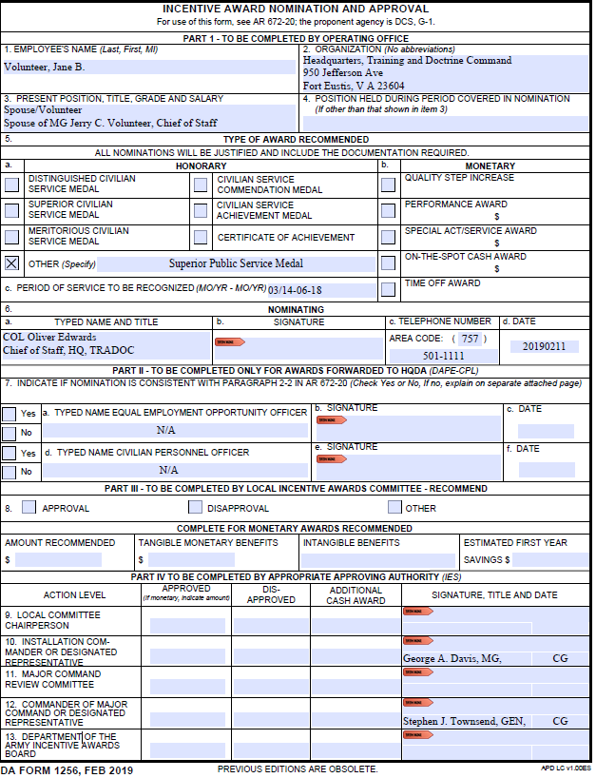

Figure 10. DA Form 1256 – Public Service Awards for Spouses 16

SAMPLE

BIOGRAPHICAL DATA

Name:

Full Address:

Work Experience:

Education/Degrees:

Professional Memberships:

Published Works:

Honors and Awards:

NOTE:

When Secretary of the Army or higher approval is requested biographical data is required.

Military and civilian spouse’s award nominations are exempt from this requirement.

Figure 12. Biographical Data –Public Service Awards

17

**SAMPLE**

**SUPPORTABLE JUSTIFICATION**

**for the**

**Superior Public Service Medal**

**During the period March 2014 to June 2018, Mrs. Volunteer exhibited exceptional individual effort to improve the quality of life for soldiers and their families at Fort Swampy. Mrs. Volunteer served in numerous official and unofficial volunteer capacities during her tenure at the installation.**

**Mrs. Volunteer single-handedly revamped and automated the entire thrift shop operation. Last year, the thrift shop realized a profit of over $60,000. As a result, many post activities were enhanced for Army families and numerous scholarships were awarded to deserving students. In 2015 and 2016, the direct results of her tireless efforts resulted in $28,000 for scholarships and $29,000 for welfare related activities. Her outstanding management skills, contagious enthusiasm, and relentless motivation led to a marked increase in membership of the Officers’ Wives Club during the last 3 years.**

**Jane Volunteer worked continuously to support the Army mission through the Army Family Team Building program. Her regular contact with the Family Support Division kept her in touch with the most critical needs facing our Army families. Student education was one of Mrs. Volunteer's top priorities. She constantly stressed the importance of education and the development of future leaders in our community. To promote this effort, she implemented a school page in the post’s weekly paper—the *Bayonet*. She also suggested that a school representative be included in the installation-wide quarterly retreat ceremony to symbolize the high priority of education at Fort Swampy.**

**One of the most significant contributions during the period was Mrs. Volunteer’s hosting of the highly successful Army Family 2016 Symposium. Mrs. Volunteer spent endless hours in planning and coordinating the activities for this Army wide conference. Since a large part of the conference focused on school age children topics, Mrs. Volunteer interfaced with local educators, school system administrators, students, and parents. At the conclusion of the conference, Mrs. Volunteer was recognized by Mrs. Shinseki, wife of the Chief of Staff of the Army, for her dedication and service to Army families.**

**NOTE: A well-supported justification describes the volunteer’s contributions in detail for the period of service being recognized. Any periods of service recognized by a previous public service award should not be used as justification for the current award. Justification**

**18**

**statements should include a description of specific voluntary services and their effect upon the community. If there are examples of cost savings, this should be included in the justification.**

**A weak justification may only state that the private citizen contributed to the welfare of the military family but fails to explain how the achievements impact the community or the Army family.**

#### Figure 13. Supportable Justification – Public Service Awards

**19**

**History of Previous Department of the Army Public Service Awards**

##### **List of public service awards with dates**

**Outstanding Civilian Service Award with Bronze Laurel Leaf Cluster, January 1996**

**Outstanding Civilian Service Award, August 1992**

**Leaders Award for Public Service, August 1989**

#### Figure 14. Awards History – Public Service Awards

**20**

**SAMPLE**

**PROPOSED CITATION**

**For extraordinary service to the United States Army Training and Doctrine Command during the period June 1996 to August 2002. Mrs. Volunteer’s dedicated and exceptional service as an Army spouse, and most importantly as a leader and community volunteer, has had a tremendous influence on service to the Army and the Nation. As a result of her tireless efforts, thousands of dollars have been given in scholarships and welfare donations. Mrs. Volunteer's enthusiasm, dedication, genuine concern for others, and sincere involvement enhanced all aspects of the family support system. The Army and the Nation will remain forever grateful for her dedicated service.**

**Presentation of this award is scheduled for (indicate a date).**

**NOTE: The citation should start with the statement “For extraordinary service” followed by the name of the command and the specific period of service.**

**Next, two or three key contributions by the volunteer should be cited.**

**In conclusion some distinctive qualities should be cited about the volunteer. For example,**

**Mrs. Volunteer’s enthusiasm, dedication and genuine concern for others, and sincere involvement enhanced all aspects of the family support system. The Army and the Nation will remain forever grateful for her dedicated service.**

**or**

**Mrs. Volunteer’s enthusiasm, dedication, genuine concern for others, and sincere involvement enhanced all aspects of the family support system and reflect great credit on her, (add the organization of the spouse, if used), and the (add command) United States Army Training and Doctrine Command.**

**The citation should be one paragraph in length consisting of 90 to 95 words. The recommended print is Arial font, 12 pitch, justified.**

#### Figure 15. Citation – Public Service Awards

**21**

**PUBLIC SERVICE**

**AWARD PROCESSING**

**CHECKLIST**

**Review award packet using checklist to ensure all applicable documentation has been included.**

**Public Service Award Nomination**

**DA Form 1256 (Feb 2019), Incentive Award Nomination and Approval.**

**Biographical data (if applicable).**

**Justification (provide achievements and resulting benefits**

**for the period nominated). NO acronyms or abbreviations.**

**Citation (NO acronyms or abbreviations).**

**List of previous public service awards.**

#### Figure 16. Award Processing Checklist – Public Service Awards

**22**

**ROUTING PROCESS**

**PUBLIC AWARD**

**For Non-civilian Employees**

**Award Processing**

**Routing of award nominations for the Distinguished Public Service Medal (DPSM), and the Superior Public Service Medal (SPSM) is as follows:**

**1. Organization submits nomination to the TRADOC Executive Secretary.**

**2. After approval of award is recommended, nomination packet is routed through the following:**

* **Dir, CHRD**
* **DCS, G-1/4**
* **DCoS**
* **DCG/CofS**
* **CG for approval or endorsement to HQDA, and**
* **Returned to the TRADOC Executive Secretary.**

**3. Approved nominations for the MPSM are returned to the organization for presentation.**

**4. Endorsed award nominations for the DPSM and SPSM are forwarded to HQDA.**

**5. Awards signed at HQDA or DoD are forwarded back to the organization to the address provided on the Awards for Approval at DA and/or DoD Form. A copy is scanned from HQDA to TRADOC Executive Secretary.**

#### Figure 17. Award Routing Process – Public Service Awards

**23**

**AWARDS FOR APPROVAL AT DA AND/OR DOD FORM**

**NOMINEES NAME: __________________________________________________**

**NAME OF AWARD: __________________________________________________**

**INFORMATION BELOW REQUIRED FOR ALL AWARDS SENT TO ARMY AND DOD FOR FINAL APPROVAL.**

**1. DATE OF PRESENTATION: ________________________________________**

**2. TIME OF PRESENTATION: _________________________________________**

**3. LOCATION OF CEREMONY: ________________________________________**

**4. IF RETIRING, MONTH/YEAR: _______________________________________**

**5. DELIVERY ADDRESS TO SEND CERTIFICATE AND MEDAL:**

**6. IF REQUESTING DELIVERY VIA FEDEX, ADD BILLING INFORMATION (W/CONTACT NAME AND COMMERCIAL PHONE NUMBER):**

**AWARDS WILL NOT BE PROCESSED BY ARMY IF ABOVE IS NOT SUBMITTED.**

**Figure 18. Awards For Approval at DA and/or DOD**

**24**

**DELEGATION OF AUTHORITY FOR CIVILAN HONORARY AND PUBLIC SERVICE AWARDS (Signed copy of delegation can be found on the TRADOC homepage under publications.)**

**Meritorious Civilian Service Medal, Civilian Service Commendation Medal, the Civilian Service Achievement Medal, and the Patriotic Public Service Lapel Pin.**

**(1) Delegate authority to approve the Meritorious Civilian Service Medal to the following positions, but only if filled by a general officer (GO) in the rank of MG and**

**above, or only by Tier 2 SES member and above:**

**• TRADOC DCG/CoS**

**• TRADOC DCoS**

**• DCS, G-1/4**

**• DCS, G-2**

**• DCS, G-8**

**(2) Delegate authority to approve the Civilian Service Commendation Medal, the Civilian Service Achievement Medal, and the Patriotic Public Service Lapel Pin to the following HQ TRADOC positions, but only if filled by a GO in the rank of BG and above, or only by Tier 1 SES member and above:**

**• TRADOC DCG/CoS**

**• TRADOC DCoS**

**• DCS, G-1/4**

**• DCS, G-2**

**• DCS, G-3/5/7**

**• DCS, G-6**

**• DCS, G-8**

**Civilian Award for Humanitarian Service. Delegate authority to Commander, Combined Arms Center, Commander, Center for Initial Military Training; and all 2-star and above commanders to approve the Civilian Award for Humanitarian Service.**

**Meritorious Public Service Medal. Delegate award approval authority to any**

**TRADOC Commander in the rank of major general or above to approve the Meritorious Public Service Medal.**

**25**